Upgrading Kubernetes cluster from Version 1.26.10 to 1.30.1

Prerequisite:

Make sure to back up any important components, such as app-level state stored in a database. kubeadm upgrade does not touch your workloads, only components internal to Kubernetes, but backups are always a best practice

The cluster should use a static control plane and etcd pods or external etcd

Swap must be disabled

Release notes
We must upgrade the K8s cluster version by version as below
- 1.26 to 1.27
- 1.27 to 1.28
- 1.28 to 1.29
- 1.29 to 1.30

Steps to Upgrade from 1.26 to 1.27

All nodes
- update the version to 1.27
cat <<EOF | sudo tee /etc/yum.repos.d/kubernetes.repo
[kubernetes]
name=Kubernetes
baseurl=https://pkgs.k8s.io/core:/stable:/v1.27/rpm/
enabled=1
gpgcheck=1
gpgkey=https://pkgs.k8s.io/core:/stable:/v1.27/rpm/repodata/repomd.xml.key
exclude=kubelet kubeadm kubectl cri-tools kubernetes-cni
EOF
- Check the packages and version using “sudo yum list --showduplicates kubeadm --disableexcludes=kubernetes”
- Install the kubeadm using “sudo yum install -y kubeadm-'1.27.14-*' --disableexcludes=kubernetes” – will update the kubeadm 1.26 to 1.27

control plane 1
- sudo kubeadm upgrade plan
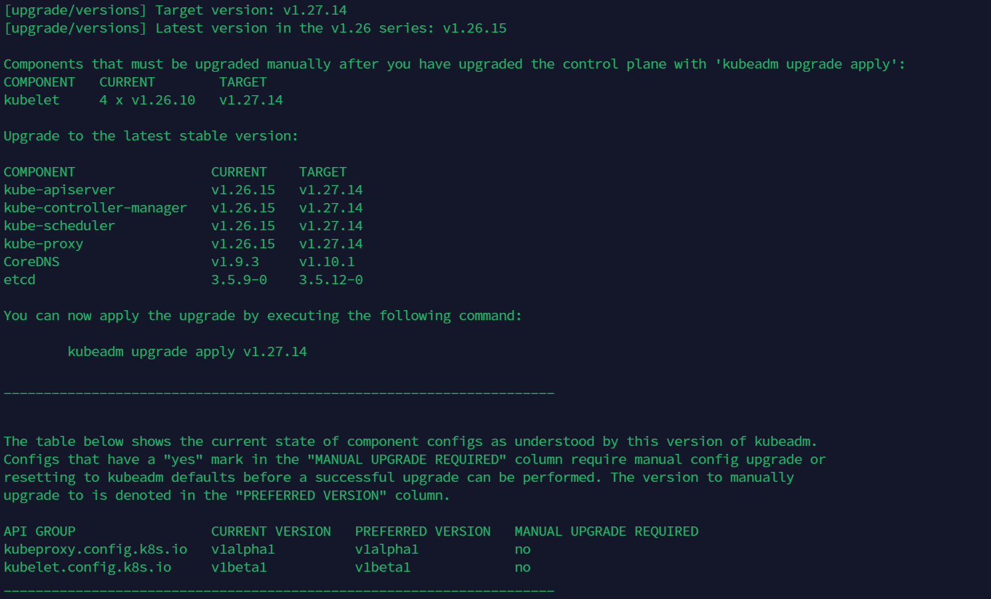
- sudo kubeadm upgrade apply v1.27.14

For the other control plane nodes
- sudo kubeadm upgrade node

For all Worker Node
- sudo kubeadm upgrade node
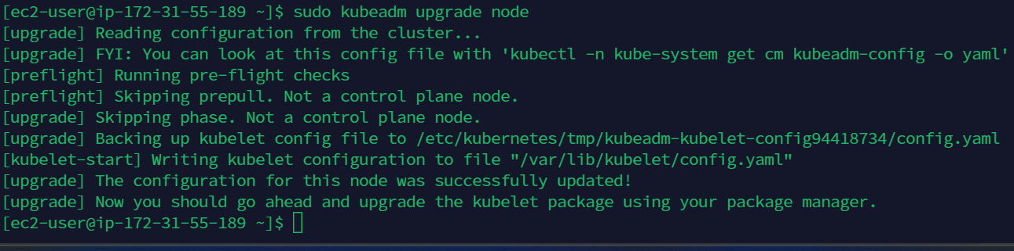

Execute the below steps one by one in all control planes and worker nodes
- kubectl drain <node-to-drain> --ignore-daemonsets – from k8s admin conf
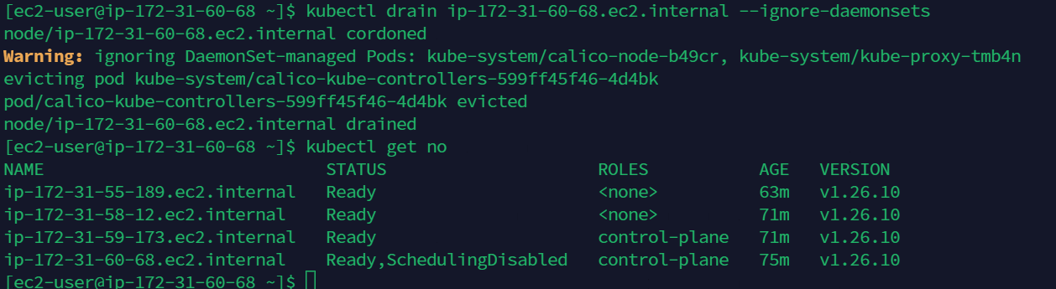
- In node (drained node) update kubelet and kubectl
sudo yum install -y kubelet-'1.27.14-*' kubectl-'1.27.14-*' --disableexcludes=kubernetes
sudo systemctl daemon-reload
sudo systemctl restart kubelet
- Now we can view the updated version of Kubernetes in control plane1
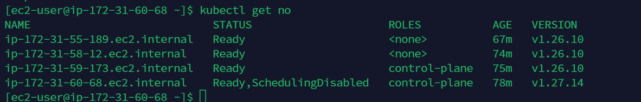
- kubectl uncordon <node-to-drain>
After following the above steps, now we can see the node updated to 1.27
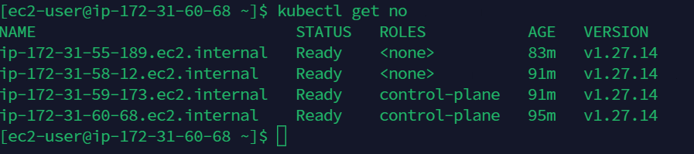

Steps to Upgrade from 1.27 to 1.28

All nodes
- update the version to 1.28
cat <<EOF | sudo tee /etc/yum.repos.d/kubernetes.repo
[kubernetes]
name=Kubernetes
baseurl=https://pkgs.k8s.io/core:/stable:/v1.28/rpm/
enabled=1
gpgcheck=1
gpgkey=https://pkgs.k8s.io/core:/stable:/v1.28/rpm/repodata/repomd.xml.key
exclude=kubelet kubeadm kubectl cri-tools kubernetes-cni
EOF
- Check the packages and version using “sudo yum list --showduplicates kubeadm --disableexcludes=kubernetes”
- Install the kubeadm using “sudo yum install -y kubeadm-'1.28.10-*' --disableexcludes=kubernetes” – will update the kubeadm 1.27 to 1.28

control plane 1
- sudo kubeadm upgrade plan
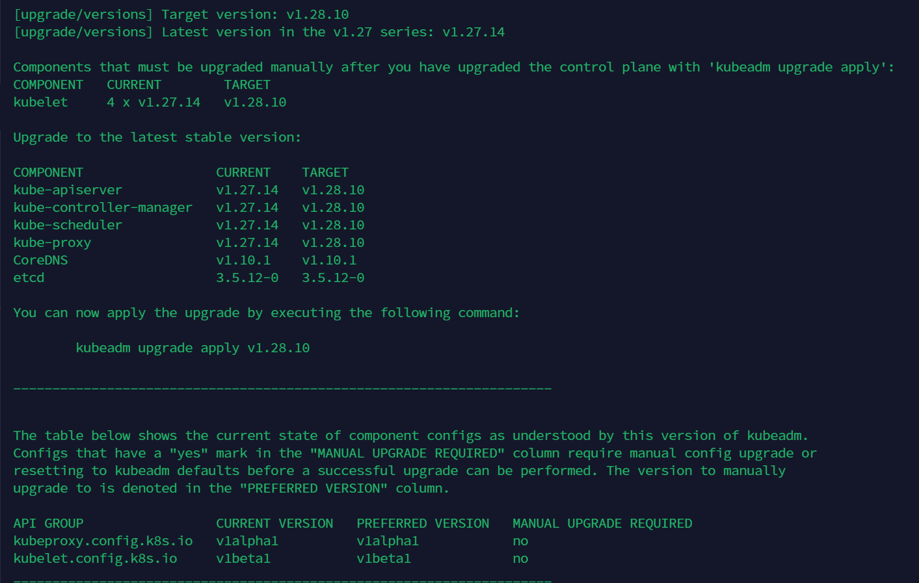
- sudo kubeadm upgrade apply v1.28.10

For the other control plane nodes
- sudo kubeadm upgrade node
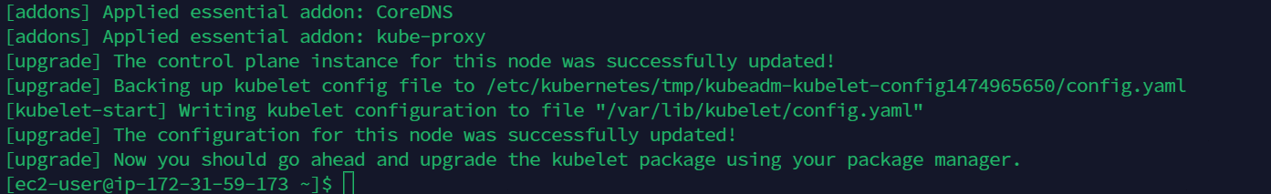

For all Worker Node
- sudo kubeadm upgrade node
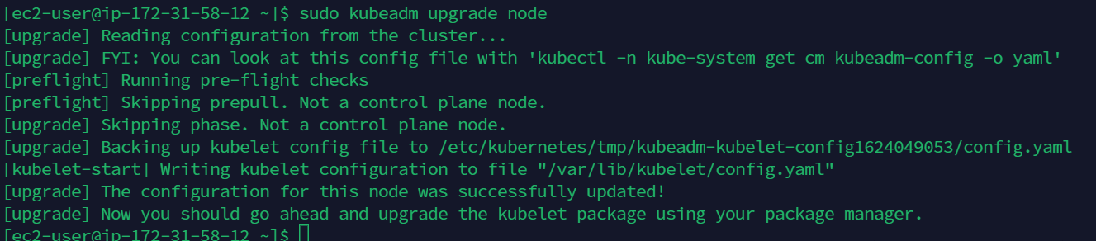

Execute the below steps one by one in all control planes and worker nodes
- kubectl drain <node-to-drain> --ignore-daemonsets – from k8s admin conf
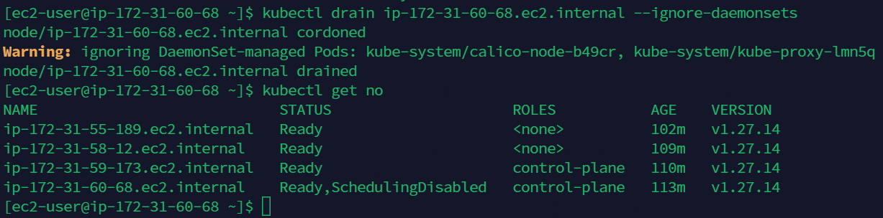
- In node (drained node) update kubelet and kubectl
sudo yum install -y kubelet-'1.28.10-*' kubectl-'1.28.10-*' --disableexcludes=kubernetes
sudo systemctl daemon-reload
sudo systemctl restart kubelet
- Now we can view the updated version of Kubernetes in control plane1
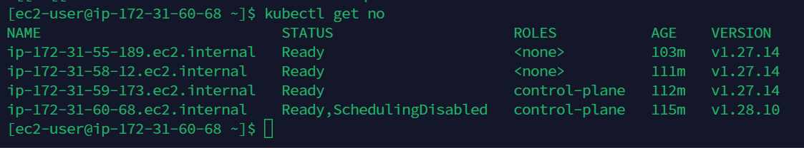
- kubectl uncordon <node-to-drain>
After following the above steps, now we can see the node updated to 1.28
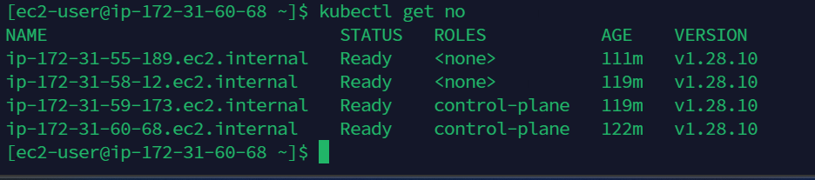

Steps to Upgrade from 1.28 to 1.29

All nodes
- update the version to 1.29
cat <<EOF | sudo tee /etc/yum.repos.d/kubernetes.repo
[kubernetes]
name=Kubernetes
baseurl=https://pkgs.k8s.io/core:/stable:/v1.29/rpm/
enabled=1
gpgcheck=1
gpgkey=https://pkgs.k8s.io/core:/stable:/v1.29/rpm/repodata/repomd.xml.key
exclude=kubelet kubeadm kubectl cri-tools kubernetes-cni
EOF
- Check the packages and version using “sudo yum list --showduplicates kubeadm --disableexcludes=kubernetes”
- Install the kubeadm using “sudo yum install -y kubeadm-'1.29.5-*' --disableexcludes=kubernetes” – will update the kubeadm 1.28 to 1.29

control plane 1
- sudo kubeadm upgrade plan
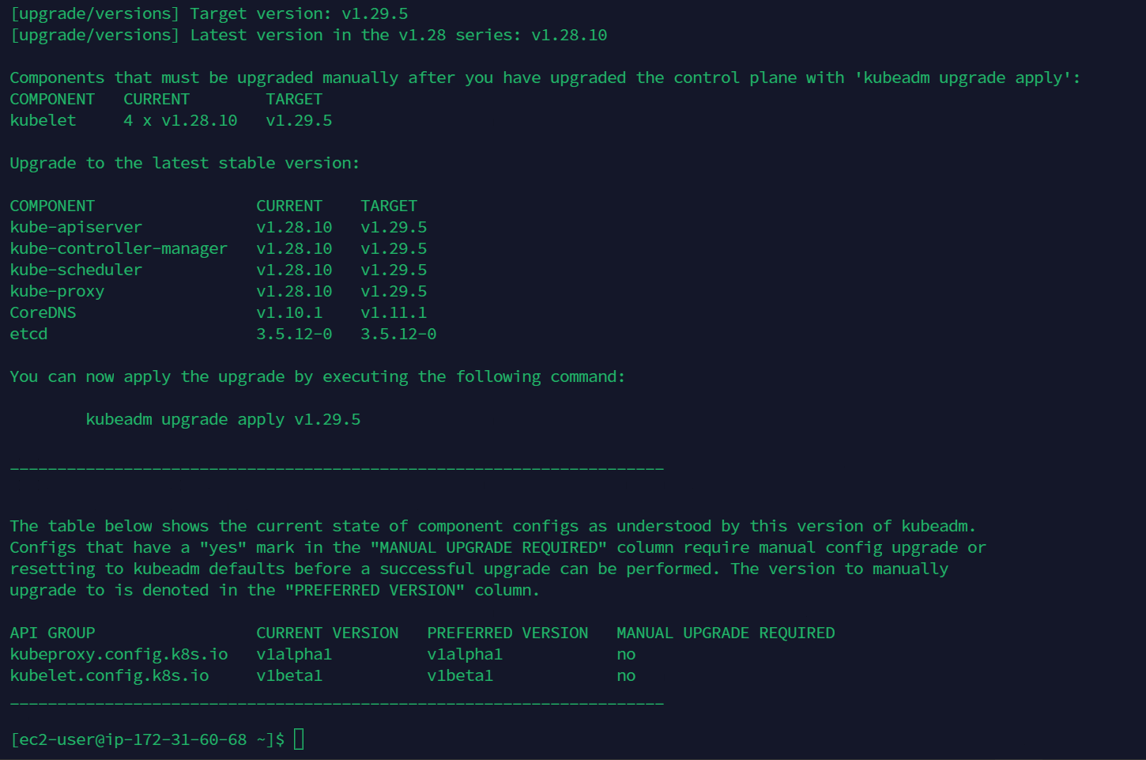
- sudo kubeadm upgrade apply v1.29.5
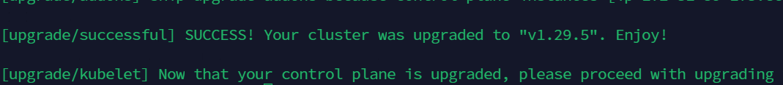

For the other control plane nodes
- sudo kubeadm upgrade node
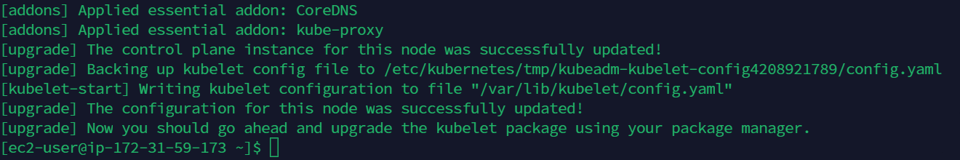

For all Worker Node
- sudo kubeadm upgrade node
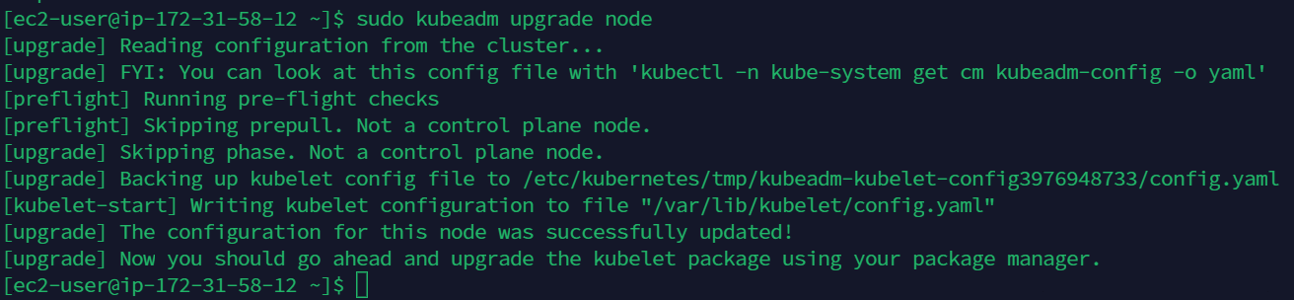

Execute the below steps one by one in all control planes and worker nodes
- kubectl drain <node-to-drain> --ignore-daemonsets – from k8s admin conf
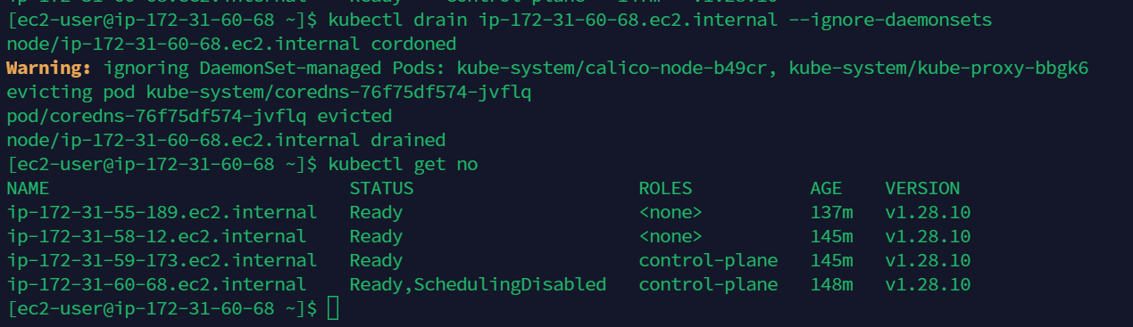
- In node (drained node) update kubelet and kubectl
sudo yum install -y kubelet-'1.29.5-*' kubectl-'1.29.5-*' --disableexcludes=kubernetes
sudo systemctl daemon-reload
sudo systemctl restart kubelet
- Now we can view the updated version of Kubernetes in control plane1
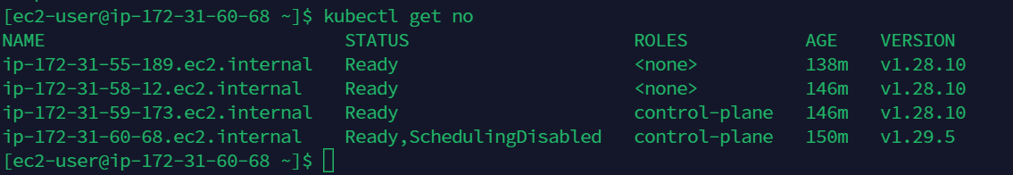
- kubectl uncordon <node-to-drain>
After following the above steps, now we can see the node updated to 1.29
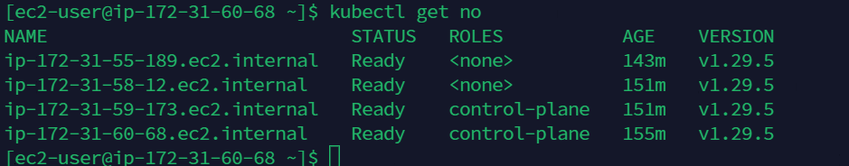

Steps to Upgrade from 1.29 to 1.30

All nodes
- update the version to 1.30
cat <<EOF | sudo tee /etc/yum.repos.d/kubernetes.repo
[kubernetes]
name=Kubernetes
baseurl=https://pkgs.k8s.io/core:/stable:/v1.30/rpm/
enabled=1
gpgcheck=1
gpgkey=https://pkgs.k8s.io/core:/stable:/v1.30/rpm/repodata/repomd.xml.key
exclude=kubelet kubeadm kubectl cri-tools kubernetes-cni
EOF
- Check the packages and version using “sudo yum list --showduplicates kubeadm --disableexcludes=kubernetes”
- Install the kubeadm using “sudo yum install -y kubeadm-'1.30.6-*' --disableexcludes=kubernetes” – will update the kubeadm 1.29 to 1.30

control plane 1
- sudo kubeadm upgrade plan
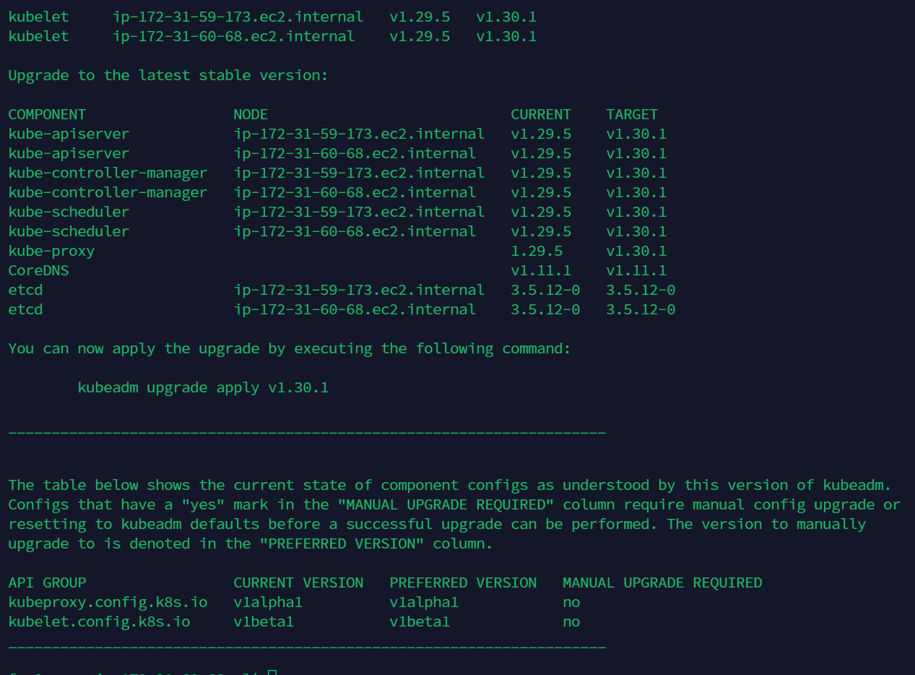
- sudo kubeadm upgrade apply v1.30.6

For the other control plane nodes
- sudo kubeadm upgrade node
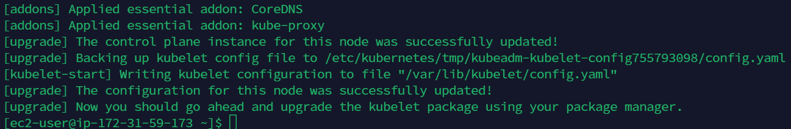

For all Worker Node
- sudo kubeadm upgrade node
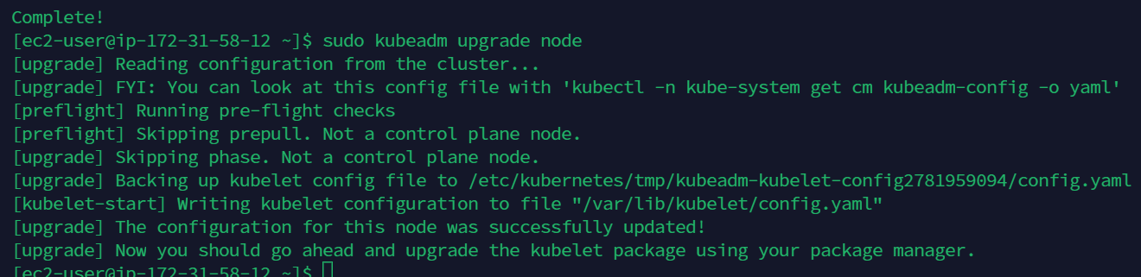

Execute the below steps one by one in all control planes and worker nodes
- kubectl drain <node-to-drain> --ignore-daemonsets – from k8s admin conf
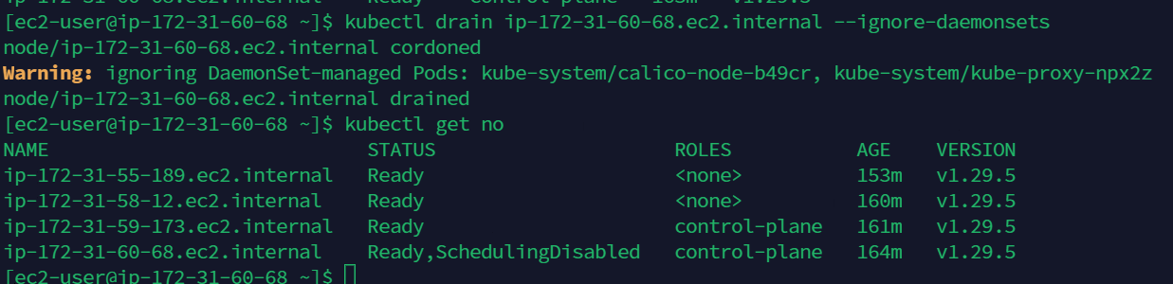
- In node (drained node) update kubelet and kubectl
sudo yum install -y kubelet-'1.30.6-*' kubectl-'1.30.6-*' --disableexcludes=kubernetes
sudo systemctl daemon-reload
sudo systemctl restart kubelet
- Now we can view the updated version of Kubernetes in control plane1
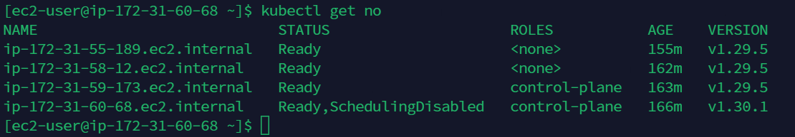
- kubectl uncordon <node-to-drain>
After following the above steps, now we can see the node updated to 1.30
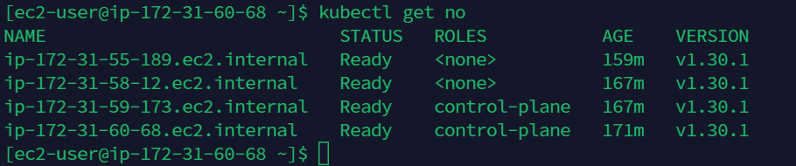

Steps to Upgrade from 1.30 to 1.31

All nodes
- update the version to 1.31
cat <<EOF | sudo tee /etc/yum.repos.d/kubernetes.repo
[kubernetes]
name=Kubernetes
baseurl=https://pkgs.k8s.io/core:/stable:/v1.31/rpm/
enabled=1
gpgcheck=1
gpgkey=https://pkgs.k8s.io/core:/stable:/v1.31/rpm/repodata/repomd.xml.key
exclude=kubelet kubeadm kubectl cri-tools kubernetes-cni
EOF
- yum clean all

- Check the packages and version using “sudo yum list --showduplicates kubeadm --disableexcludes=kubernetes”
- Install the kubeadm using “sudo yum install -y kubeadm-'1.31.1-*' --disableexcludes=kubernetes” – will update the kubeadm 1.30 to 1.31

control plane 1
- sudo kubeadm upgrade plan
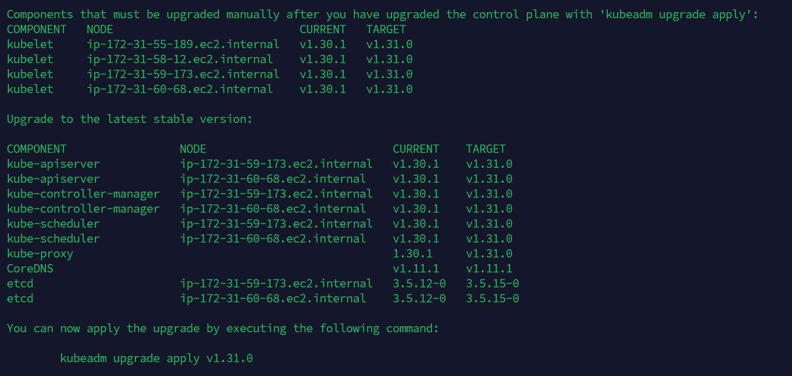
- sudo kubeadm upgrade apply v1.31.1

For the other control plane nodes
- sudo kubeadm upgrade node

For all Worker Node
- sudo kubeadm upgrade node

Execute the below steps one by one in all control planes and worker nodes
- kubectl drain <node-to-drain> --ignore-daemonsets – from k8s admin conf
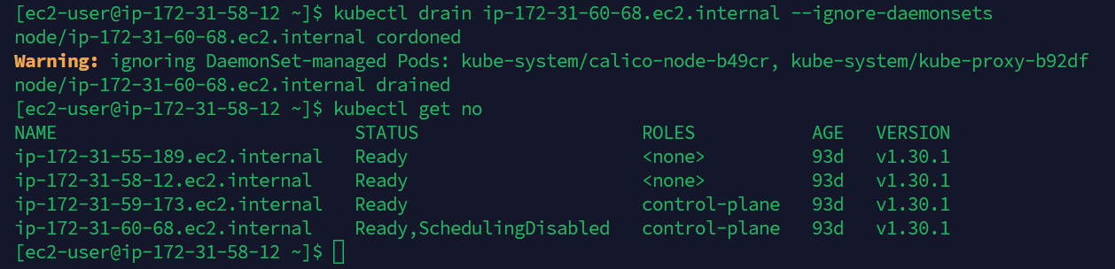
- In node (drained node) update kubelet and kubectl
sudo yum install -y kubelet-'1.31.6-*' kubectl-'1.31.6-*' --disableexcludes=kubernetes
sudo systemctl daemon-reload
sudo systemctl restart kubelet
- Now we can view the updated version of Kubernetes in control plane1
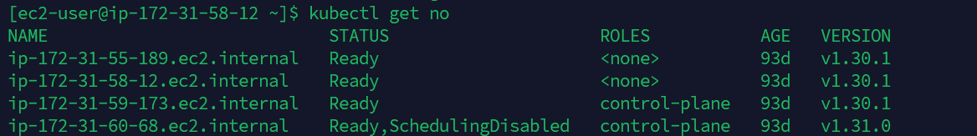
- kubectl uncordon <node-to-drain>
After following the above steps, now we can see the node updated to 1.31

